Justification of Temperature Derating in Compliance with EV5.8.4
  - Table of Contents
1 Introduction 3
2 Test Done Under Setup One 4
3 Observations and Justification to Change Setup 7
4 Test Done Under Setup Two 10
5 Observations of Setup Two 11
6 Analysis and result 14
7 Conclusions 18
8 References 18

Lists of images, tables and equations
- Setup1 images.
- Equation used to convert raw Arduino readings to absolute temperature.
  - $R_(th)=R_(fixed)*\frac{1023-N}{N}$
  - $T_{abs}=\frac{1}{\frac{1}{T_{0}}+\left(\frac{1}{B}\right)\ln\left(\frac{R_{th}}{R_{0}}\right)}$
  - $T_{abs}=\frac{1}{\left(\frac{1}{298.15}\right)+\left(\frac{1}{3380}\right)\ln\left(\frac{\frac{10000\left(1023-N\right)}{N}}{10000}\right)}$
  - $T_{C}=T_{abs}-273.15$
- Reference link to data collection log 1 setup 1.
- Graph of Temperature variation of thermistor readings in SEPNA SP284 and HM706 thermal grease against time for log 1 setup 1.
- Reference link to data collection log 2 setup 1.
- Graph of Temperature variation of thermistor readings in SEPNA SP284 and HM706 thermal grease against time for log 2 setup 1.
- Reference link to data collection log 3 setup 1 – where metal sheet piece with sensors attached was moved.
- Setup 2 images.
- Reference link to data collection log 1 setup 2.
- Graph of Temperature variation of thermistor readings in SEPNA SP284 and HM706 thermal grease against time for log 1 setup 2.
- Graph of Temperature difference of thermistor readings in SEPNA SP284 and HM706 thermal grease against time for log 1 setup 2.
- Reference link to data collection log 2 setup 2.
- Graph of Temperature variation of thermistor readings in SEPNA SP284 and HM706 thermal grease against time for log 2 setup 2.
- Graph of Temperature difference of thermistor readings in SEPNA SP284 and HM706 thermal grease against time for log 2 setup 2.
- Equations used to determine Steady State.
  - $ΔT_{i}=T_{a0,i}-T_{a1,i}$
  - $Slope_{a0}=\frac{T_{a0,i}-T_{a0,i-w}}{t_{i}-t_{i-w}}$ , w = 50 (sampling at 10Hz, slope considered for 5s window)
  - $Slope_{a1}=\frac{T_{a1,i}-T_{a1,i-w}}{t_{i}-t_{i-w}}$
  - $σ_{ΔT}=std\left(ΔT_{i-w},…,ΔT_{i}\right)$
  - classified as steady state when all the following conditions are satisfied
    - $\left|Slope_{a0}\right|≤0.08 °\frac{C}{s}$
    - $\left|Slope_{a1}\right|≤0.08 °\frac{C}{s}$
    - $σ_{ΔT}≤0.35 °C$
- How derated shutdown temperature is computed.
  - $T_{shutdown,derated}=T_{cell,limit}-ΔT_{error}$
  - $ΔT=Maximum steady state offset for {60}^{o} C$

Introduction
The purpose of this document is to demonstrate that Team Falcon E Racing is in full compliance with EV 5.8.4, which states:
“If thermal adhesive is used to ensure contact between the cell and the temperature sensor, the maximum monitored temperature shall be appropriately derated in the ESF.”
To substantiate compliance with this requirement, a series of experimental evaluations were conducted using two distinct test configurations. The initial configuration did not yield repeatable or verifiable results and was therefore deemed insufficient for compliance validation. Consequently, a revised test configuration was implemented to address the identified limitations and improve measurement reliability.
The revised configuration produced consistent and repeatable results across all test iterations. Based on the validated experimental data, it is concluded that the monitored maximum temperature shall be derated to 59 °C (rounded) for ESF compliance purposes.

Test Done Under Setup One
Raw analog voltage readings from the Arduino were transmitted via serial communication and logged onto a laptop using a custom Python-based data acquisition script. The recorded data was subsequently processed to compute temperature values using the above conversion model.
Temperature measurements were obtained using a voltage divider configuration powered by a 5 V supply, as illustrated below:
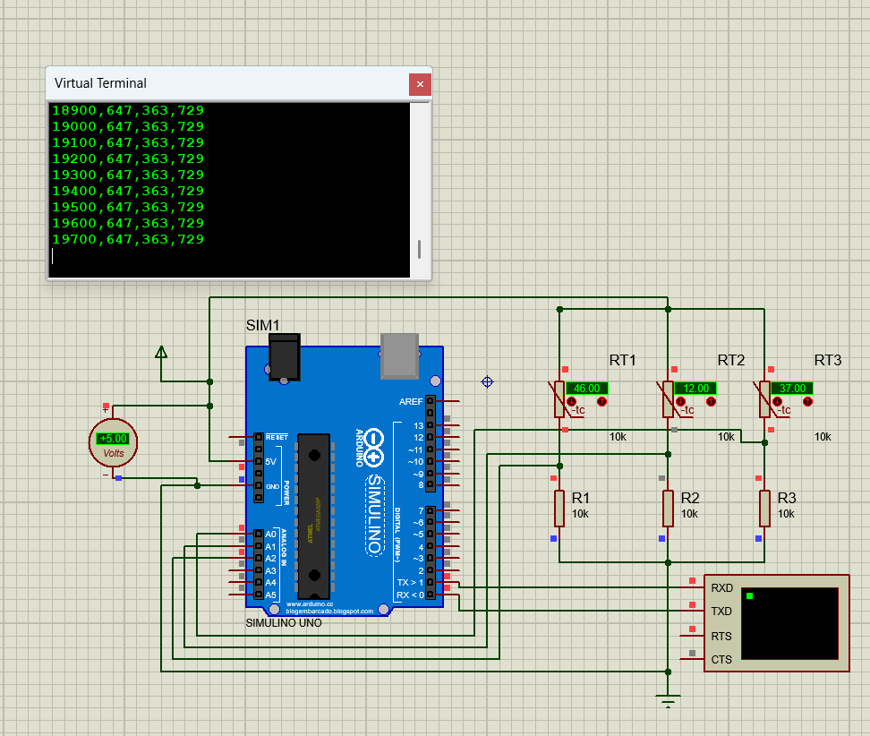
Three independent thermistor channels were implemented for comparative evaluation:
- A0: HM706 thermal grease interface
- A1: SEPNA SP284 thermal adhesive interface
- A3: Room temperature was measured during testing; however, it was not included in the analytical model, as its effect is negligible for the thermistor-based relative temperature measurement approach used in this study. The parameter was recorded for completeness, future extensibility of the analysis, and consistency with standard experimental reporting conventions.

Actual Setup
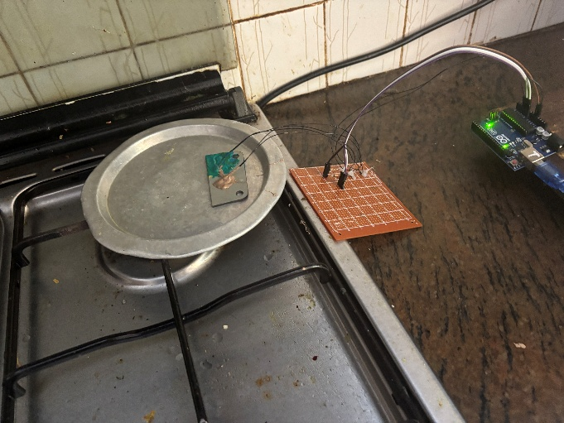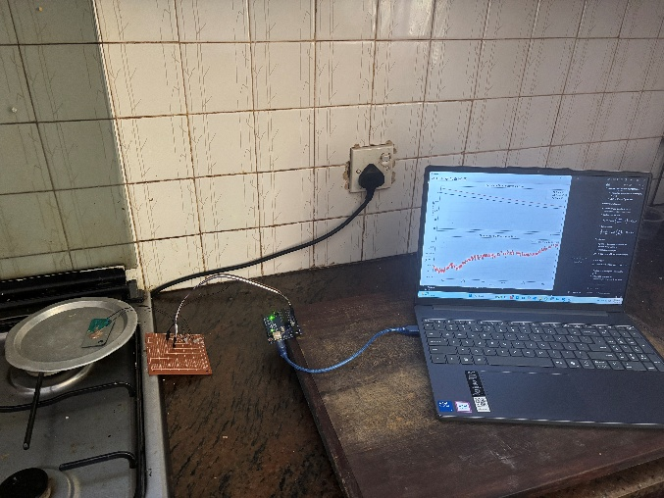
Parameter Definitions
- N = Arduino ADC reading from analog Read () (0–1023)
- R_fixed = 10,000 Ω
- R₀ = 10,000 Ω (reference resistance)
- B = 3380 K (Beta constant)
- T₀ = 298.15 K (25 °C reference temperature)

Thermistor Conversion Methodology
Raw analog readings from the Arduino (0–1023 ADC counts) were converted into absolute temperature using the standard Beta parameter thermistor model.
Thermistor Resistance Calculation
$$R_{th}=R_{fixed}⋅\frac{1023-N}{N}$$
Absolute Temperature Calculation
$$T_{abs}=\frac{1}{\left(\frac{1}{T_{0}}+\frac{1}{B}ln⁡\left(\frac{R_{th}}{R_{0}}\right)\right)}$$
Substituting system constants:
$$T_{abs}=\frac{1}{\left(\frac{1}{298.15}+\frac{1}{3380}ln⁡\left(\frac{10000(1023-N)}{N⋅10000}\right)\right)}$$
Conversion to Celsius
$$T_{C}=T_{abs}-273.15$$
Arduino data acquisition firmware:
https://drive.google.com/file/d/1MZwLOtrtMPWxh-VFR8HZfA4SiASOaNuR/view?usp=sharing
Python data logging and processing script:
https://drive.google.com/file/d/1wBnDJra4b3pjJh-68qWDxw_SEkvz-tNy/view?usp=sharing
Video of Simulation
https://drive.google.com/file/d/1gc_St_TjDv6X3T7EVNot6Qxg1mEV0yBL/view?usp=sharing
Video of Actual Test
https://drive.google.com/file/d/1g42lfbsJEdEXDrycqZ9ckika14TgSrux/view?usp=sharing

Observations and Justification to Change Setup
Link to data collection log 1 setup 1
https://docs.google.com/spreadsheets/d/1mNYYlSfvsYYSMqiVTfuS36CgHKaELMPO/edit?usp=drive_link&ouid=108335454301995161498&rtpof=true&sd=true

The observed results from the initial experimental run cannot be considered reliable, as the system response was not repeatable across test conditions. Although the thermal loading of the setup was increased, the battery compound appeared to exhibit a higher absolute temperature compared to the thermal grease. This behavior is inconsistent with expected thermal performance based on material properties.
It is noted that the thermal conductivity of HM706 thermal grease is 2.58 W/m·K [1], while SEPNA SP284 is 1.2 W/m·K [2]. Based on these manufacturer-specified values, the thermal grease is expected to provide superior thermal conduction performance. Therefore, the observed deviation is attributed to experimental variability rather than true material behavior.

Link to data collection log 2 setup 1
https://docs.google.com/spreadsheets/d/1WMyF1LId-ly7ccjHYEQv0dWo_nCfUWCa/edit?usp=sharing&ouid=108335454301995161498&rtpof=true&sd=true

In a separate repeat of the experiment, the thermal grease demonstrated higher absolute temperature compared to the battery compound, which is consistent with theoretical expectations. However, due to inconsistencies between test iterations, the overall experimental results cannot be considered fully repeatable. As a result, the initial findings are not used as a basis for quantitative conclusions.
A third experimental iteration was conducted in which a slight mechanical displacement was introduced to the metal sheet placed on the heating plate during the test. This was performed to assess the sensitivity of the measurement system to variations in contact conditions. Reference link to data collection log 3 setup 1.
https://docs.google.com/spreadsheets/d/1oX33QOv9luFKVeGD69DIb0eCTTszf8vX/edit?usp=drive_link&ouid=108335454301995161498&rtpof=true&sd=true

It was observed that, following the displacement, the thermal grease exhibited a higher temperature compared to the battery compound. This change in relative behavior indicates that the measured results are highly dependent on contact conditions and interface stability.
Based on these observations, it is concluded that the temperature distribution across the heating plate and metal sheet is not spatially uniform. This non-uniformity is likely influenced by the localized heating profile of the heat source (hearth flame), resulting in uneven thermal gradients across the test surface.
Consequently, it is inferred that maintaining the current experimental setup makes it extremely challenging to achieve consistent and uniform heat transfer conditions, thereby limiting the repeatability and reliability of comparative thermal measurements under this configuration.

Test Done Under Setup Two
In the revised experimental setup, the metal sheet was no longer placed directly on a heated metal plate. Instead, it was immersed in a container filled with well-stirred hot water. This modification was introduced to improve thermal uniformity and reduce spatial temperature gradients observed in the previous setup, thereby providing more consistent and repeatable boundary conditions for thermal measurements.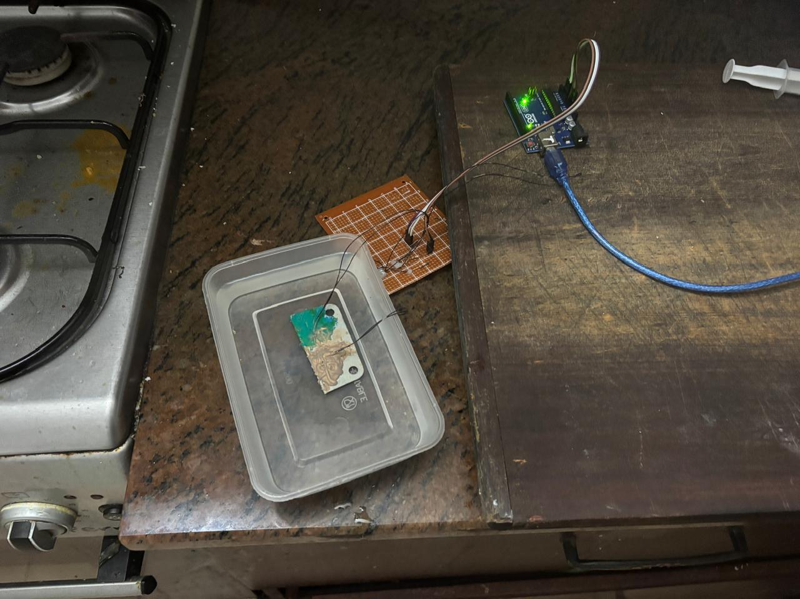

Video of Actual Test
https://drive.google.com/file/d/1sfMfdtOE2YPh6cyJB6bbEgJofoxw96WG/view?usp=drive_link

Observations of Setup Two
Reference link to data collection log 1 setup 2.
https://docs.google.com/spreadsheets/d/1d0RRSLlIG76I_n1F7ySofqONRpE0FT-k/edit?usp=sharing&ouid=108335454301995161498&rtpof=true&sd=true

Although the measured temperatures are very close throughout the experiment, the results are sufficient to validate the expected thermal behaviour. As discussed previously, the HM706 thermal grease, having a higher manufacturer-specified thermal conductivity (2.58 W/m·K) than SEPNA SP284 (1.2 W/m·K), is theoretically expected to transfer heat more effectively, resulting in a slightly higher measured sensor temperature under identical test conditions.
To verify this expectation, the temperature difference between the two thermistors was evaluated as
$$ΔT=T_{\text{HM706}}-T_{\text{SEPNA SP284}}.$$
A positive value of $ΔT$indicates that the thermistor coupled using HM706 thermal grease records a higher temperature than the thermistor bonded using SEPNA SP284, consistent with the expected thermal performance. Demonstrating this behaviour provides experimental evidence that the test methodology is consistent with the underlying thermal characteristics of the interface materials.

As shown in the results, $ΔT$remains positive for the majority of the experiment, indicating that the thermistor coupled with HM706 thermal grease generally measures a slightly higher temperature than the thermistor bonded with SEPNA SP284. The small fluctuations observed in $ΔT$are attributed primarily to measurement uncertainty and sensor noise, and do not alter the overall trend.
Data acquired during the addition of hot water was excluded from this analysis. During this transient period, the incoming hot water reaches one sensor before the other, producing temporary temperature gradients within the container. Consequently, the two thermistors are not exposed to identical thermal conditions until the water is thoroughly mixed and both sensors are fully submerged. Measurements recorded during this interval are therefore not representative of the steady-state thermal response and were omitted from the comparison.

Reference link to data collection log 2 setup 2.
https://docs.google.com/spreadsheets/d/1psTs99BQPt6_eynAgh7ztH7xbbCGIjbY/edit?usp=sharing&ouid=108335454301995161498&rtpof=true&sd=true
Graph of Temperature variation of thermistor readings in SEPNA SP284 and HM706 thermal grease against time for log 2 setup 2.

Graph of Temperature difference of thermistor readings in SEPNA SP284 and HM706 thermal grease against time for log 2 setup 2.

Analysis and result
Steady-State Detection Methodology
To ensure that the temperature offset between the two thermistors was evaluated only under stable thermal conditions, an automated steady-state detection algorithm was implemented in the data processing script (derive_derated_shutdown.py).
For each sampled data point $i$, the algorithm evaluates the preceding 5-second time window and verifies that the thermal system satisfies three independent stability criteria:
- The rate of change of temperature of Thermistor A0 (HM706 thermal grease) is sufficiently small.
- The rate of change of temperature of Thermistor A1 (SEPNA SP284) is sufficiently small.
- The temperature difference between the two thermistors remains statistically stable throughout the evaluation window.
The temperature difference between the two sensors is defined as
$$ΔT_{i}=T_{A0,i}-T_{A1,i}$$
where:
- $T_{A0}$= Temperature measured by the thermistor coupled using HM706 thermal grease.
- $T_{A1}$= Temperature measured by the thermistor bonded using SEPNA SP284.

Temperature Slope Calculation
The average temperature slope over the preceding 5-second window is calculated for each thermistor as
$${\text{slope}}_{A0}=\frac{T_{A0,i}-T_{A0,i-w}}{t_{i}-t_{i-w}} \\ {\text{slope}}_{A1}=\frac{T_{A1,i}-T_{A1,i-w}}{t_{i}-t_{i-w}}$$
where $w$represents the number of samples corresponding to a 5-second interval.
The stability of the temperature difference is quantified by calculating the standard deviation of the offset over the same evaluation window:
$$σ_{ΔT}=std⁡\left(ΔT_{i-w},…,ΔT_{i}\right)$$
A sample is classified as steady state only if all the following conditions are simultaneously satisfied:
$$∣{\text{slope}}_{A0}∣≤0.08 ^{∘}C/s \\ ∣{\text{slope}}_{A1}∣≤0.08 ^{∘}C/s \\ σ_{ΔT}≤0.35 ^{∘}C$$(The numerical thresholds were selected empirically based on the noise characteristics of the experimental measurement system and validated through repeatability testing.)
These thresholds ensure that both thermistors have reached a sufficiently stable thermal condition while maintaining a consistent temperature offset.
To prevent isolated data points or short-duration fluctuations from being incorrectly classified as steady state, consecutive steady-state samples are grouped into continuous segments. A segment is accepted only if its duration is 15 seconds or longer. Shorter segments are rejected as transient events.
Each recorded sample is assigned the following attributes during post-processing:
- process step – Identifies the stage of the experimental procedure.
- process group – Groups consecutive samples belonging to the same process stage.
- SteadyState – Boolean indicator specifying whether the sample satisfies all steady-state criteria.
Only samples identified as belonging to valid steady-state segments were used in the subsequent analysis to determine the thermal offset and derive the required temperature derating in accordance with EV 5.8.4.

Derivation of the Derated Shutdown Temperature
In accordance with EV 5.8.5, the maximum permissible battery cell temperature is 60 °C. Since the temperature sensor is not mounted directly on the cell but is coupled through a thermal interface material, a temperature offset exists between the measured sensor temperature and the actual cell temperature. To ensure that the true cell temperature does not exceed the regulatory limit, a derated sensor shutdown temperature was determined based on the experimentally measured offset.
The temperature difference between the two thermistors was evaluated only during validated steady-state conditions, as described in the previous section. From all steady-state data, the following statistical measures of the temperature offset were obtained:
The derated shutdown temperature is calculated by subtracting the selected temperature offset from the maximum allowable cell temperature:
$$T_{shutdown,derated}=T_{cell,limit}-ΔT_{error}$$
Where,
- $T_{shutdown,derated}$= Sensor shutdown temperature after derating,
- $T_{cell,limit}$= Maximum allowable cell temperature specified by EV 5.8.5 (60 °C),
- $ΔT_{error}$= Experimentally determined temperature offset.
From a scientific perspective, two approaches can be adopted to determine the temperature offset, $ΔT_{error},$used for sensor derating. The first is a conservative approach, in which the maximum observed steady-state temperature offset is selected as $ΔT_{error}$ The second is a robust statistical approach, in which the 95th percentile (P95) of the steady-state temperature offset distribution is used. The 95th percentile is always less than or equal to the maximum observed steady state offset, making the conservative approach inherently more protective. As the battery temperature monitoring system is a safety-critical function subject to stringent Formula Student EV safety requirements, adopting the maximum observed steady-state temperature offset provides the greatest safety margin against measurement uncertainty. Consequently, the maximum observed steady-state temperature offset was selected as $ΔT_{error}$for the derivation of the derated shutdown temperature.

Python Data Processing Script
https://drive.google.com/file/d/1DTXDY9Jn_WVnimpNS6LwskMkT6dyJNbL/view?usp=sharing
As two independent experimental datasets satisfied the validation criteria described in the preceding sections, both datasets were processed to determine the corresponding derated shutdown temperature. Applying the same analysis methodology to multiple valid datasets provides additional confidence in the repeatability and robustness of the proposed derating approach.
The steady-state classification results for each dataset are presented below.
https://drive.google.com/file/d/1P7p-WmbXcVYiGeUAL2GNIZJ6ziFlM-Uq/view?usp=drive_link
https://drive.google.com/file/d/1WPBB_aH8TTahHWSUz_KZwpKbNtSJwpkl/view?usp=sharing
The calculated derated shutdown temperatures obtained from the two experimental datasets are summarized below:
- Log 1: 59.4858 °C
- Log 2: 59.1492 °C
Both experimental results indicate a derated shutdown temperature of approximately 59 °C. To ensure compliance with the conservative derating methodology adopted in this study and to provide an additional safety margin, the Battery Management System (BMS) shutdown threshold shall be set to 59 °C. This value ensures that the actual cell temperature remains below the maximum permissible limit of 60 °C, thereby satisfying the requirements of EV 5.8.4 and EV 5.8.5 under the validated experimental conditions.

Conclusions
A repeatable experimental methodology was successfully established to evaluate the temperature offset introduced by the thermal interface material between the battery cell and the temperature sensor. The steady-state detection and filtering approach ensured that only thermally stable and statistically consistent data were used for analysis, thereby improving the reliability of the measured offset.
Based on the validated steady-state measurements, the maximum observed temperature offset was used to derive a conservative sensor derating in accordance with the requirements of EV 5.8.4. Consequently, a Battery Management System shutdown threshold of 59 °C is justified, ensuring that the actual battery cell temperature remains below the maximum permissible limit of 60 °C, while also incorporating an appropriate safety margin to account for measurement uncertainty and interface-induced thermal lag.
Furthermore, the chosen experimental configuration using thermal grease is considered appropriate for representing real-world sensor mounting conditions. Direct immersion of the thermistor into the fluid medium would eliminate the thermal interface layer and therefore not accurately represent the thermal resistance present in practical battery management system installations. The use of a thermal interface material ensures a controlled and repeatable contact condition between the sensor and the test surface, enabling a realistic evaluation of thermal coupling effects under conditions consistent with practical engineering implementation.
Overall, the methodology provides a conservative and physically representative basis for temperature derating, ensuring compliance with Formula Student EV safety requirements while maintaining experimental validity and repeatability.

References
[1] Chipset Electronic Technologies Inc., “HM706-TU25B 2.58W/m·K 25GR Thermal Paste,” Atom Bilişim, [online]. Available: https://www.atombilgisayar.com/hm706-tu25b-thermal-paste-1335. Accessed: Jul. 3, 2026.
[2] [1] Shanghai SEPNA Chemical Technology Co., Ltd., “SP284 1.2W Light Weight Thermally Conductive Structural Adhesive for NEV Battery Bonding,” Made-in-China.com, [Online]. Available: https://sepna.en.made-in-china.com/product/WTzRqjndYLVE/China-Sp284-1-2W-Light-Weight-Thermally-Conductive-Structural-Adhesive-for-Nev-Battery-Bonding.html. Accessed: Jul. 3, 2026.
[3] National Institute of Standards and Technology (NIST), "Mercury Thermometer Alternatives: Thermistor", National Institute of Standards and Technology, 2011. [Online]. Accessed: Jul. 3, 2026.

